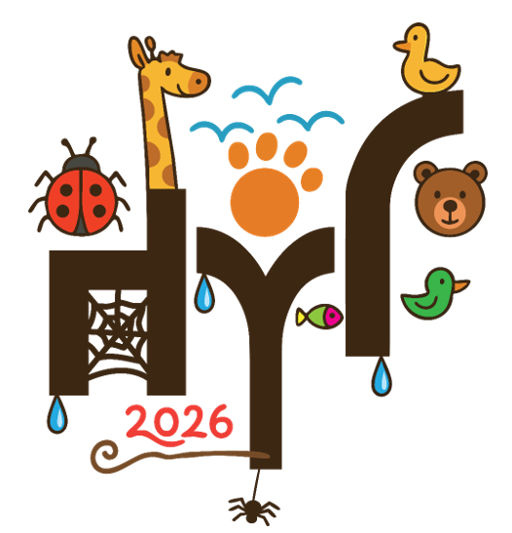 |  | School Workshop  Application Form  March 2026
SCHOOL
Contact Name
Position
E-Mail
Telephone
Please return Application Form to: | Please complete all contact details above and all the pages with event details.  Please remember to write your school name in the top row.  When complete, please send to Daniel Sadler at schools@hyf.org.uk (Tel: 07776303858) below by 6 February 2026
Please note: | The performances this year will be held in schools. The workshops will take place in schools by arrangement with the providers as we are aware that this makes logistics much easier for schools.  When timetabling we will try our utmost to ensure an equitable allocation of workshop places. We hope to be able to arrange for at least one workshop in each school.  We will share provisional workshop dates with schools to make sure there are no clashes with internal events.  Please indicate on the attached form which performances or workshops you would ideally like us to arrange for your pupils.

DETAILS OF WORKSHOPS / PERFORMANCES |  |  |  |  |  |  |  |  |  |  |  |  |  | COLUMNS FOR SCHOOL TO COMPLETE
SCHOOL NAME: |  |  |  |  |  |  |  | Would you like to attend?  Yes/No |  |  | Number of children you would like to attend in years available? |  |  |  |  |  |  |  |  |  |  |  |  |  |  |  |  |  |  | How many wheelchair users are there?
DAY | DATE | YEAR GROUP | MAX NO. | LOCATION | TIMES | DURATION | COST PER CHILD | Would you like to attend?  Yes/No | R |  | Year 1 |  |  | Year 2 |  |  | Year 3 |  |  | Year 4 |  |  | Year 5 |  |  | Year 6
Workshops
Berkshire Birds
TBC | TBC | Y2 – Y6 | 30 | TBC | TBC | TBC | Free
African Djembe Drums and Percussion Workshop
TBC | TBC | Y1 – Y6 | 30 | TBC | TBC | TBC | Free
African Dance Workshop
TBC | TBC | Y2 – Y6 | 30 | TBC | TBC | TBC | Free
Emily Cooling
TBC | TBC | Y4 – Y6 | 30 | TBC | TBC | TBC | Free
Create and Make
TBC | TBC | Y2 – Y5 | 30 | TBC | TBC | 60 mins | Free
Kathryn Fell – Digital Photography
TBC | TBC | Y4 – Y6 | 30 | TBC | TBC | 60 mins | Free
Flamenco
TBC | TBC | R – Y1 | 30 | TBC | TBC | TBC | Free

Performances
What You Will
Thurs | 12/3 | 5 / 6 | 90 | School TBC | TBC | TBC | £4.00
Thurs | 12/3 | 5 / 6 | 90 | School TBC | TBC | TBC | £4.00
Fri | 13/3 | 5 / 6 | 90 | School TBC | TBC | TBC | £4.00
Fri | 13/3 | 5 / 6 | 90 | School TBC | TBC | TBC | £4.00
Circus Skills Science Show
TBC | TBC | Y2 – Y6 | TBC | TBC | TBC | TBC | £4.00
TBC | TBC | Y2 – Y6 | TBC | TBC | TBC | TBC | £4.00
TBC | TBC | Y2 – Y6 | TBC | TBC | TBC | TBC | £4.00
Please return completed form to schools@hyf.org.uk by 6 February 2026

