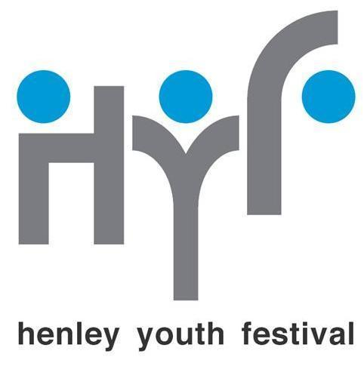

Privacy Policy

The Henley Youth Festival is passionate about providing opportunities for Henley’s young people and use personal data in running our competitions and events. We are also keen to keep spreading our news to our many friends and supporters as well as sending out vital news updates. However, we are committed to ensuring we only contact those who want to be contacted and that we hold people’s details securely.
Our Privacy Policy below sets out how we use the information that you give us and how we keep it safe. This privacy notice provides information on how HYF collects and processes your personal data when you visit our website to sign up for our newsletter or promotional emails, or where you enter one of our HYF Events or Competitions.

1. Important information and who we are

Henley Youth Festival Trust is the controller and responsible for your personal data.
If you have any questions about this privacy notice or our data protection practices please contact the data protection officer at info@hyf.org.uk

CONTACT DETAILS
Our full details are: Henley Youth Festival Trust
Charity number: 1044280
Email address: info@hyf.org.uk
Postal address: Berrywood, Stoke Row Road, Kingwood, RG9 5NG

2. The data we collect about you

We may collect, use, store and transfer different kinds of personal data about you as follows:
• Identity Data includes first name, last name, age and date of birth, parent or guardian details (if required), school year and school.
• Contact Data includes postal address, email address and telephone numbers set out on the Entry Forms or in the subscription to our newsletter.
• Medical Data includes any information you provide if you complete our Medical Form.
• Marketing and Communications Data includes your preferences in receiving marketing from us and our third parties and your communication preferences if you sign up to receive our newsletter.

3. How we use your personal data

We will only use your personal data for the purpose for which we collected it which include the following:
• To register you as an entrant of our events and competition or an attendee to our launch events
• To contact you about the events or competitions, such as rehearsals.
• To contact you if you register your interest in being a volunteer or chaperone or steward at an event.
• To manage our events and competitions and publicise results in the local press (depending on photo permissions given).
• To enable you to participate in our events and competition or launch events.

Newsletter subscribers:
• Subscribers opt-in to our mailing list so that we can keep them better informed via email bulletins about dates, latest developments and upcoming events. We only hold names and email addresses of subscribers.
• Subscriber data is collected via opt-in sections on entry forms, operational emails or pop-up forms on our website and social media.

4. How we share your personal data

The data we collect will only be used by HYF and will not be shared with third parties. All email communications from us will be solely about HYF, its activities, fundraising and information on specific events at the festival. We will not be promoting other organisations.
We use MailChimp to deliver our email updates. For more information, please see MailChimp’s privacy notice. You can unsubscribe to our general mailings at any time by clicking the unsubscribe link at the bottom of any of our emails or by emailing our data protection officer at admin@hyf.org.uk

5. Children’s data processing

We have fully reviewed the Information Commissioner's Office guidance on processing the personal data of children and recognise that children require specific protection with regard to their personal data as they may be less aware of the risks, consequences and safeguards concerned and their rights in relation to the processing of personal data.

We make sure that our processing is fair and complies with the data protection principles. We have ensured that we only hold the minimal amount of personal data required in order to run our events and competitions and ask for parent or guardian permission to be given on entry forms and for a correspondence address of such parent or guardian. We have highlighted rights over personal data below and will ensure that we comply with these rights, especially the right to erasure.

6. International transfers

Henley Youth Festival is based within the UK, however some of our external third parties may be based outside the UK (such as Mailchimp) so their processing of your personal data will involve a transfer of data outside the UK.
Whenever we transfer your personal data out of the UK, we ensure a similar degree of protection is afforded to it by ensuring we will only transfer your personal data to countries that have been deemed to provide an adequate level of protection for personal data.

7. Your legal rights

Under certain circumstances, you have rights under data protection laws in relation to your personal data including the right to receive a copy of the personal data we hold about you and the right to make a complaint at any time to the Information Commissioner's Office, the UK regulator for data protection issues (www.ico.org.uk).
This includes your right to access your personal data; request rectification; object to processing and have your personal data erased.
More detail can be found here.

8. Security and Retention

We have put in place appropriate security measures to prevent your personal data from being accidentally lost, used or accessed in an unauthorised way, altered or disclosed. In addition, we limit access to your personal data to those volunteers and other third parties who have a need to know. They will only process your personal data on our instructions and they are subject to a duty of confidentiality.
We have put in place procedures to deal with any suspected personal data breach and will notify you and any applicable regulator of a breach where we are legally required to do so.
We will only retain your personal data for as long as reasonably necessary to fulfil the purposes we collected it for.

